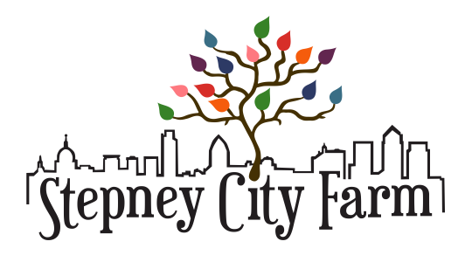

Farm Club Volunteer Role Description

ROLE OVERVIEW

Are you passionate about animals, plants, food and farming? Do you enjoy working with young people?

We are looking for enthusiastic individuals who can help to run a weekly volunteering session for 12-18yr olds on Sundays. There are two sessions to choose from; mornings (9:30-1:00pm), or afternoons (1:00-5:30pm). You don't have to come every week but we ask for a minimum commitment of 1 session a month.

This post is an exciting opportunity for someone who is looking to gain hands on experience of working with young people within an environmental organisation.

DETAILS

Location: | Stepney City Farm, Stepney Way, London, E1 3DG
Salary and benefits: | This is a voluntary role. Reasonable expenses will be reimbursed.  Relevant training provided when possible.  Lunch is provided if you volunteer for both sessions.
Hours: | Sundays, 9:30-1:00pm or 1:00-5:30pm.  We ask for a minimum commitment of 1 session a month.
Deadline for application: | Ongoing
Responsible to: | Farm Education Officer

ABOUT STEPNEY CITY FARM

Stepney City Farm is a Registered Charity based in Tower Hamlets. There are various animals on-site including donkeys, goats, chickens and ducks so the main focus of the day-to-day running of the farm is caring for the animals. The organisation also seeks to provide educational opportunities for the local community with regards to animal care, gardening and rural crafts. We run a Community Growing Club, rent out cheap allotment space, work in partnership with local Schools and Youth Clubs and are home to a Rural Arts Centre.

PROJECT DESCRIPTION

Stepney City Farm holds a wealth of knowledge regarding animal husbandry, gardening and rural crafts. Where possible we seek to share this knowledge with young people in the local area. Since November 2010 we have been running a volunteer session for 12-18yr olds to gain experience of farming on Sunday afternoons. The young people often run stalls at events to raise funds for things like seeds, animal leads and other equipment. Regular tasks include cleaning animal houses, grooming donkeys, walking animals, watering plants, maintaining our Children's Garden, painting signs and much more.

MAIN RESPONSIBILITIES

Main activities / tasks:

- Support the session leader to run weekly volunteer sessions on Sundays
- Research and learn about animal care and gardening
- Help to ensure that we are evaluating and monitoring the project

PERSON SPECIFICATION

Essential | Desirable
Enthusiasm for working with children and young people | Awareness of Child Protection issues
Keen interest in gardening and animal care | Experience of working with animals and/or Knowledge and understanding of organic growing
Ability to interact with a diverse range of people and age groups | Previous work with children and young people
A responsible person with common sense and the ability to spot potential hazards
Willingness to get stuck in to work on a farm
Ability to work on Sundays

As with all positions working with young people on the farm, this post is dependent upon the successful completion of a DBS check.

FURTHER INFORMATION

What we can offer you:

- Possible external training opportunities regarding working with young people
- Hands on experience of working with young people for an environmental organisation
- Learning opportunities relating to animal husbandry, gardening and working with young people

To apply, please complete the volunteer application form here along with a short cover letter (no more than one side of A4) describing why you would like this position and how you meet the criteria outlined above. Email this to youth@stepneycityfarm.org

